**OBJECTIVES**

By the end of this module, you should be able to:

* Recognize the specific challenges of multi‐objective problems and how to address them
* Use a simple additive utility model to solve multiple‐objective problems using direct trade‐off methods or negotiated solutions
* Understand the method of ‘swing‐weighting’ to elicit the values of decisionmakers
* Understand some techniques for reducing the complexity of multiple‐objective problems, or transforming them to single‐objective problems

**MULTIPLE OBJECTIVE PROBLEMS**

* What makes them complicated?
* Objectives are usually described on different scales – We have to trade ‘apples for oranges’
* Too much information to process informally (System 1 can get overwhelmed)
* Different stakeholders or decision makers may have different values (value objectives differently)
* Nearly all natural resource problems are multiple-objective problems

**STRUCTURING MULTIPLE OBJECTIVE PROBLEMS**

* Tradeoffs require clear rationale and transparency – use PrOACT
* Additional considerations at the “T” stage:
* Quantification of the value preferences (weights) across objectives
* A logical analytical approach to tradeoffs

**SOLVING A MULTIPLE OBJECTIVE PROBLEM BY SIMPLIFICATION**

1. Start by simplifying - minimize complexity as best you can
2. Then:
   1. Reduce to a single-objective problem
      * Either:
      * Transform all but one objectives into constraints
      * Combine objectives into a single attribute
      * Then, solve using single-objective optimization tools
   2. Solve as a multiple objective problem
      * Use a multi-objective tradeoff method
      * Facilitate a negotiated solution

***START BY SIMPLIFYING THE PROBLEM***

* Identify any *dominated alternatives*
* On all objectives, at least one other alternative performs the same or better
* Identify any *“irrelevant” objectives*
* Performance measures do not vary over alternatives
* This isn’t to say the objective isn’t important to you, just that it doesn’t help discern among these particular alternatives
* Consider *even swaps* (merging an objective into another one)
* Combine two objectives into one when they can be placed in the same units

***Example****:* Impoundment Repair

*Dominated alternatives:* On all objectives, at least one other alternative performs the same or better.

|  |  |  |  |  |
| --- | --- | --- | --- | --- |
| **Objectives** | **Alternatives** | | | |
| Status quo | Minor repair | Major repair | Re-build |
| Cost ($M) | 0 | 2 | 12 | 20 |
| Environmental Benefit (0-10) | 1 | 3 | 10 | 10 |
| Disturbance  (0-10) | 0 | 1 | 7 | 10 |
| Silt runoff (k ft3) | 5 | 1 | 3 | 3 |
| Water Retention (MG) | 41 | 41 | 41 | 39 |

*Efficient Frontier.* The boundary at which no objective can be better achieved without some sacrifice relative to another objective. The optimal solution is located on the efficient frontier, but where on the frontier depends on how the tradeoffs among objectives are valued.

***Example*:** American Shad Management (Nehlsen et al. 2008, USFWS Region 5, SDM Workshop). Each dot on the graph is the projected outcome of one decision alternative (an alternative is a portfolio of individual actions) in terms of cost ($, x‐axis) and “population benefit” (constructed scale, y‐axis).

Lowest Cost Option

Highest Benefit Option

Inefficient Options

Compromise Options

150000

200000

250000

300000

350000

14

16

18

20

22

Cost ($)

Population Benefit

*Irrelevant objectives:* Performance measures for an objective do not vary over alternatives.

|  |  |  |  |  |
| --- | --- | --- | --- | --- |
| **Objectives** | **Alternatives** | | | |
| Status quo | Minor repair | Major repair | Re-build |
| Cost ($M) | 0 | 2 | 12 | 20 |
| Environmental Benefit (0-10) | 1 | 3 | 10 | 10 |
| Disturbance  (0-10) | 0 | 1 | 7 | 10 |
| Silt runoff (k ft3) | 5 | 1 | 3 | 3 |
| Water Retention (MG) | 41 | 41 | 41 | 39 |

*Even swaps:*

* The goal is to express one objective in terms of another. The consequences to each objective are kept, but one objective is accounted for in terms of the other.
* Set the first objective to the same value for all alternatives by transferring the differences into the second objective
* Remove the (now) irrelevant first objective
* Remove any dominated alternatives that might result

**Mitigating silt runoff estimated to cost $0.5M / k ft3**

|  |  |  |  |  |
| --- | --- | --- | --- | --- |
| **Objectives** | **Alternatives** | | | |
| Status quo | Minor repair | Major repair | Re-build |
| Cost ($M) | 0 + 2 = 2 | 2 | 12 + 1 = 13 | 20 |
| Environmental Benefit (0-10) | 1 | 3 | 10 | 10 |
| Disturbance (0-10) | 0 | 1 | 7 | 10 |
| Silt runoff (k ft3) | 5 – 4 = 1  $ 2 M | 1  $ 0 M | 3 – 2 = 1  $ 1 M | 3 |
| Water Retention (MG) | 41 | 41 | 41 | 39 |

*Reduced problem*

|  |  |  |  |
| --- | --- | --- | --- |
| **Objectives** | **Alternatives** | | |
| Status quo | Minor repair | Major repair |
| Cost ($M) | 2 | 2 | 13 |
| Environmental Benefit (0-10) | 1 | 3 | 10 |
| Disturbance  (0-10) | 0 | 1 | 7 |

***REDUCE TO A SINGLE-OBJECTIVE PROBLEM***

Simplifying the problem to a single objective allows you to identify the best alternative using a wide range of tools.

* Option 1: Turn all objectives except one into constraints, and solve as a constrained optimization problem
* Set thresholds for all objectives but one (i.e., satisfy a minimum level), rather than seeking to optimize all of them
* A common, intuitive solution method
* Follows a well‐understood heuristic (the lexicographic approach, see Module 1), e.g., rather than “minimize budget”, objective addressed by staying within a fixed budget amount
* Objective maintained is often the most important
* Constraints represent highly restrictive tradeoffs
* Careful consideration needed
* e.g., an alternative costing $1 above constraint won’t be considered, regardless of the increased benefits produced
* Solution method: constrained optimization
* Optimizes an objective with constraints on other variables
* Linear, non-linear, integer, and goal programming

***Linear Programming Example***: Timber Harvest

* You are a forest manager interested in maximizing timber yield while minimizing costs
* Conditions:
* 300 ac eligible for harvest, with 200 ac of a 40‐yr stand, and 100 ac of a 60‐yrstand.
* Labor Costs. Harvesting the 40‐yr stand requires 1.5 person‐days/ac; harvesting the 60‐yr stand requires 4.5 person‐days/ac.
* The expected yield is 3000 ft3/ac from the 40‐yr stand, and 5000 ft3/ac from the 60‐yr stand.
* Problem: How much of each stand should you harvest to maximize the yield?
* Objectives
* Maximize yield
* Minimize cost
* Alternatives
* Choose a portfolio of how many acres to harvest of 40‐yr and 60‐yr timber (i.e., a portfolio)
* Consequences (model)
* Input: x = acres of 40‐yr, y = acres of 60‐yr
* Yield (ft3) = 3000x + 5000y

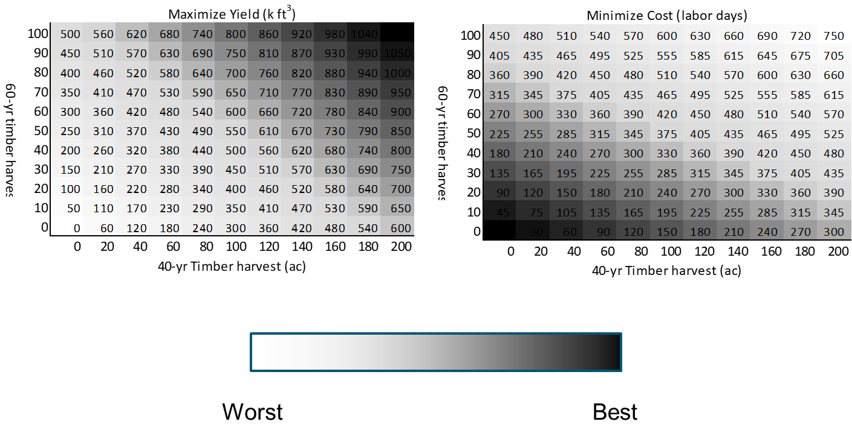

* Constraints
  + 300 acres available (imposed)
  + 40-yr stand (x) – 200 acres: 0 ≤ x ≤ 200
  + 60-yr stand (x) – 100 acres: 0 ≤ y ≤ 200
  + Labor available = 525 person-days: 1.5x + 4.5y ≤ 525
  + 1.5 person-days/ac for 40-yr stand
  + person-days/ac for 60-yr stand
  + Objective to maximize – Expected yield = 3000x + 5000y
  + 3000 ft3/ac in 40-yr stand (x)
  + 5000 ft3/ac in 60-yr stand (y)

**Solution via Linear Programming (constrained optimization)**

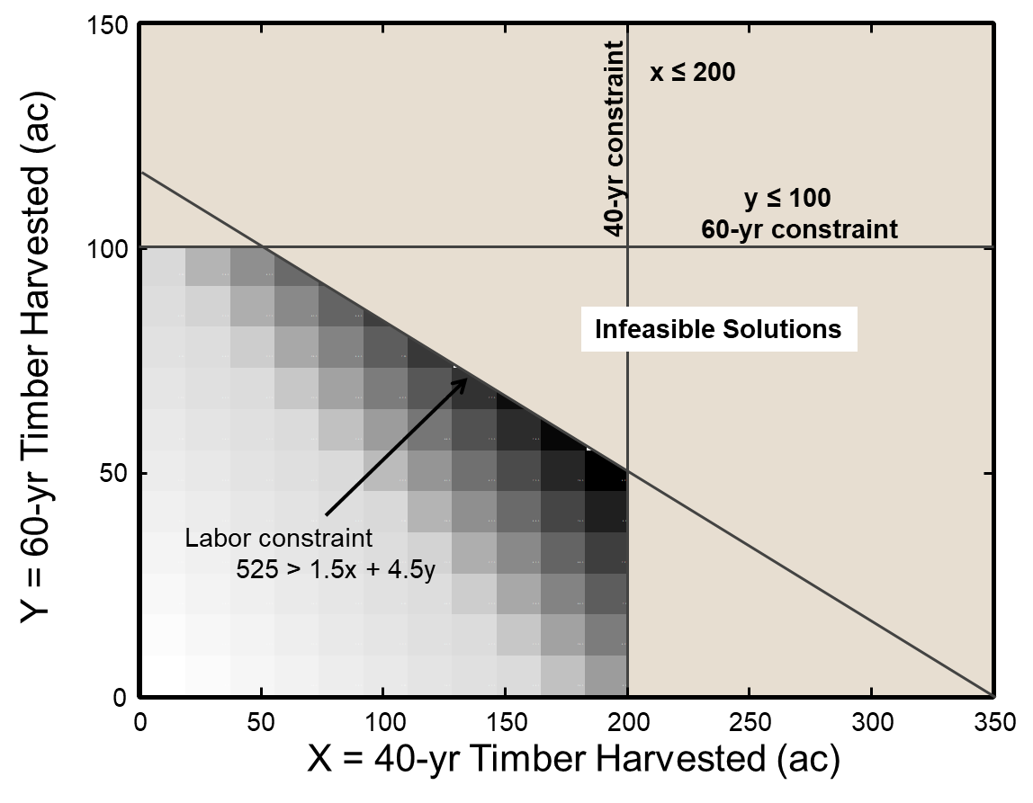



**40-yr constraint**

**x ≤ 200**

0

50

100

150

200

250

300

350

0

50

100

150

X = 40-yr Timber Harvested (ac)

Y = 60-yr Timber Harvested (ac)

**y ≤ 100**

**60-yr constraint**

Labor constraint

525 > 1.5x + 4.5y

**Infeasible Solutions**



**40-yr constraint**

**x ≤ 200**

0

50

100

150

200

250

300

350

0

50

100

150

X = 40-yr Timber Harvested (ac)

Y = 60-yr Timber Harvested (ac)

**y ≤ 100**

**60-yr constraint**

Labor constraint

525 > 1.5x + 4.5y

**Infeasible Solutions**

* Option 2: Combining objectives
* Requires creativity to express the intent of multiple objectives with a single attribute
* Objective function
* Combining multiple objectives into a single objective function
* Can be constructed scale or mathematical combination
* Differs from direct method in that trade-offs are implicit in anticipated outcomes

***Example: Reserve Creation***

* Problem: Potential loss of an endangered species
* Objectives:
* Maintain population persistence
* Minimize cost
* Maximize public acceptance
* Alternatives:
* Create and manage a 100 km2 reserve
* Do nothing
* Two possible consequences (at the end of 10 years):
* The population persists or
* The population goes locally extinct
* How are these actions and outcomes valued? Each combination of action and outcome has:
* Potential costs
* Reserve construction
* Public dissatisfaction
* Potential benefits
* Species persistence
* Public satisfaction
* Values combined into a single, constructed value
* Various means for combining objective functions into a single value

|  |  |  |  |
| --- | --- | --- | --- |
| **Objective function Valuation** | | **Decision** | |
| Establish | Don’t Establish |
| Consequence | Persist | 70 | 100 |
| Extinct | 20 | 0 |

With this information, how is the decision problem solved?

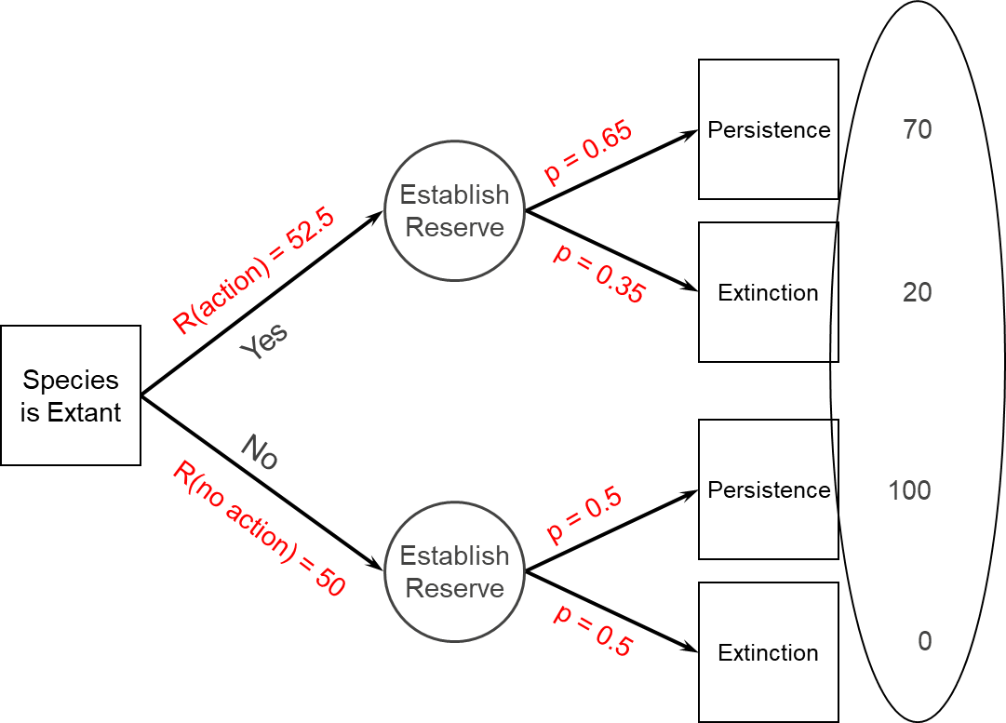

**SOLVING A MULTIPLE‐OBJECTIVE PROBLEM WITH DIRECT TRADE‐OFF METHODS**

* Basics of direct tradeoff methods solve multiple‐objective problems by
* Assign preference weights to each objective,
* Convert all the scores (consequences) for each objective to a standardized scale (e.g., 0‐1)
* Calculate a summed, weighted score for each alternative
* The highest score represents the best alternative, relative to the others
* Different methods include:
* SMART (Simple Multi‐Attribute Ranking Technique)
* AHP (Analytic Hierarchy Process)
* Goal Programming
* Others

*SMART Tradeoff Method ‐ Simple Multi‐Attribute Rating Technique (Goodwin and Wright 2004)*

* Standardize all attributes to 0‐1 scale
* Assign weights to each attribute with swing weighting
* Calculate weighted sum of scores for each alternative
* Identify the alternative with the highest weighted score
* Evaluate results for insights and sensitivity

***Example*:** SMART spreadsheet for Impoundment Repair

|  |  |  |  |  |  |  |
| --- | --- | --- | --- | --- | --- | --- |
| **Consequence Matrix** | | | **Alternatives** | | | |
| **Objectives** | **Units** | **Goal** | **Status Quo** | **Minor Rep** | **Major Rep** | **Rebuild** |
| **Cost** | **$M** | **Min** | **1** | **0.9** | **0.4** | **0** |
| **Environ Benefits** | **0 - 10** | **Max** | **0** | **0.22** | **1** | **1** |
| **Disturbance** | **0 - 10** | **Min** | **1** | **0.9** | **0.3** | **0** |
| **Silt runoff** | **Kft3** | **Min** | **0** | **1** | **0.5** | **0.5** |
| **Water retention** | **MG** | **Max** | **1** | **1** | **1** | **0** |

Standardized scores

To maximize: *nij* = (s*ij* – min(s*j*)) / (max(s*j*) – min(s*j*))

To minimize: *nij* = (s*ij* – max(s*j*)) / (min(s*j*) – max(s*j*))

Where *n*= standardized score, *s* = raw score, *i* = the alternative, *j* = the objective

|  |  |  |  |  |  |  |  |
| --- | --- | --- | --- | --- | --- | --- | --- |
| **Consequence Matrix** | | | | **Alternatives** | | | |
| **Objectives** | **Units** | **Goal** | **Wt** | **Status Quo** | **Minor Rep** | **Major Rep** | **Rebuild** |
| **Cost** | **$M** | **Min** | **0.2** | **0.2** | **0.18** | **0.08** | **0** |
| **Environ Benefits** | **0 - 10** | **Max** | **0.4** | **0** | **0.089** | **0.4** | **0.4** |
| **Disturbance** | **0 - 10** | **Min** | **0.15** | **0.15** | **0.135** | **0.045** | **0** |
| **Silt runoff** | **Kft3** | **Min** | **0.2** | **0** | **0.2** | **0.1** | **0.1** |
| **Water retention** | **MG** | **Max** | **0.05** | **0.05** | **0.05** | **0.05** | **0** |
| Sum of Weights (for all objectives) | | | **1.0** |  |  |  |  |
| Sum of weighted scores | | | | 0.40 | 0.65 | 0.68 | 0.50 |
| **Final Score** | | | | **0.40** | **0.65** | **0.68** | **0.50** |

*How do you assign weights?*

* Weights represent the relative values a decision maker places on different objectives
* Must be elicited from the stakeholders/decisionmaker(s)
* Variety of methods (Hajkowicz & Collins 2007; Stillwell et al. 1987; Gregory et al. 2012)
* Direct elicitation of weights
* Swing weighting
* Relative ranking
* Pairwise weighting (Analytic Hierarchy Process)
* Weights are context‐dependent
* If you change the range of scores for an attribute, its weight may need to change
* In other words, preferences among objectives are context specific – not just the abstract importance of an objective
* Direct weighting can be misleading in this regard!
* Swing weights allow the relative weight of an objective to depend upon the particular values available in the decision context (i.e., the range of actual alternatives)
* Swing weights use the ‘swing’ or range from the worst to the best predicted outcomes across the actual alternatives *(not the standardized or 0‐100 values)* to help elicit context‐specific preferences

*Swing weighting (for detailed steps, see Appendix at end of module)*

***Example****:* Swing weighting (buying a car)

|  |  |  |  |  |  |  |  |  |  |
| --- | --- | --- | --- | --- | --- | --- | --- | --- | --- |
| **Objective** | |  |  | **Range** | | **Hypothetical Alternatives (car)** | | | |
|  | Description | Attribute | Goal | Worst | Best | Benchmark | 1 | 2 | 3 |
|  |  |  |  |  |  |  |  |  |  |
| **A** | Life span | years | max | 6 | 12 | 6 | 12 | 6 | 6 |
| **B** | Price | $(1,000) | min | 24 | 8 | 24 | 24 | 8 | 24 |
| **C** | Color | natural | max | yellow | red | Yellow | Yellow | Yellow | Red |
|  |  |  |  |  |  |  |  |  |  |
|  | Rank | (1 is best; 4 is worst) | | | | 4 | 2 | 1 | 3 |
|  | Score | (100 is best; 0 is worst) | | | | 0 | 70 | 100 | 5 |
|  | Weight | score/(sum of scores) | | | | 0 | 0.40 | 0.57 | 0.03 |

**Thought experiment**: What happens if the range of alternatives for an objective is small (or nonexistent)?

Facilitate a negotiated solution

* Sometimes it’s not possible to reduce the problem to summing weighted objectives
* When might this be the case?
* Alternative: direct negotiation
  + Search for an ‘efficient frontier’
  + Negotiate a solution

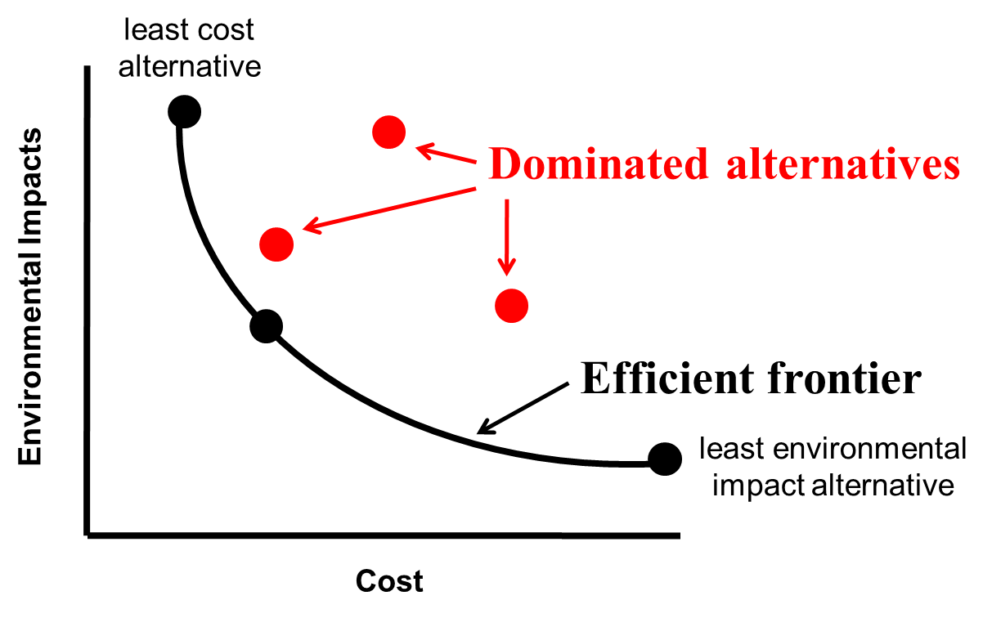

**Uncertainty**

* What types of uncertainty might you face in a multiple objective problem?
* How would you deal with uncertainty in a multiple‐objective problem?
* The most straightforward way is sensitivity analysis
* Repeat the analysis, varying the scores and weights over their ranges of uncertainty
* Check for robustness of the recommended alternative

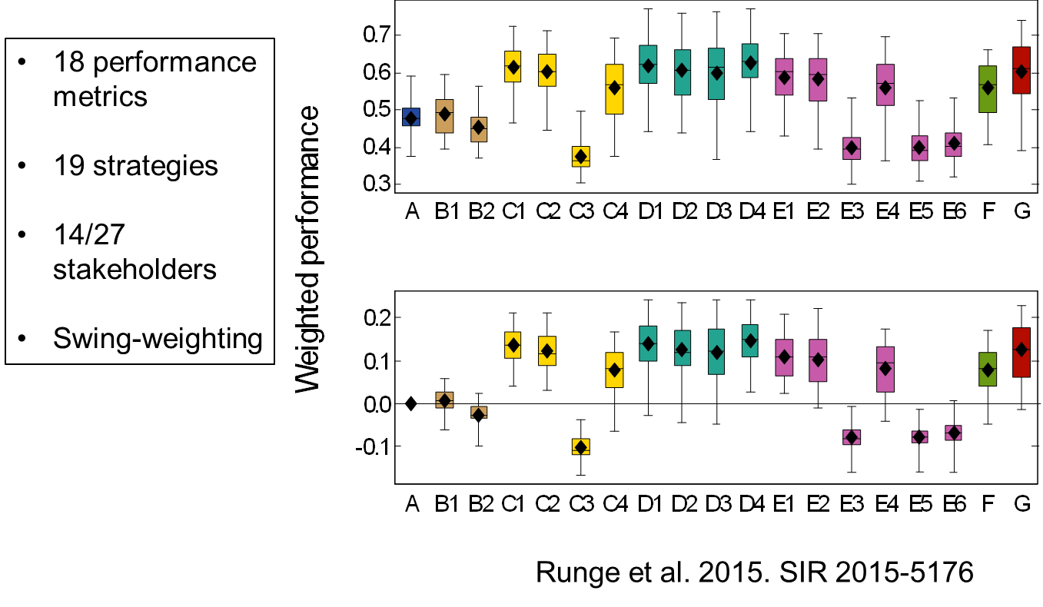

**REFERENCES**

Clemen RT, Reilly T. 2001. Making Hard Decisions with Decision Tools. Duxbury, Pacific Grove, CA.

Goodwin P, Wright G. 2004. Decision Analysis for Management Judgment. West Sussex, UK: John Wiley & Sons.

Converse SJ. 2020. Introduction to multi-criteria decision analysis. Pages 51-61 *in* MC Runge, SJ

Converse, JE Lyons, and DR Smith. Structured decision making: case studies in natural resource management. Johns Hopkins University Press, Baltimore, Maryland, USA.

Converse SJ, CT Moore, MJ Folk, and MC Runge. 2013.A matter of tradeoffs: reintroduction as a

multiple objective decision. Journal of Wildlife Management 77:1145-1156.

Gregory R, Failing L, Harstone M, Long G, McDaniels T, Ohlson D. 2012. Structured Decision Making: a

Practical Guide for Environmental Management Choices. West Sussex, United Kingdom: Wiley‐Blackwell.

Hajkowicz SA, Collins K. 2007. A review of multiple criteria analysis for water resource planning and

management. Water Resources Management 21:1553–1566.

Hajkowicz SA, McDonald GT, Smith PN. 2000. An evaluation of multiple objective decision support

weighting techniques in natural resource management. Journal of Environmental Planning and Management 43:505‐518.

Keeney RL, Raiffa H. 1993. Decisions with multiple objectives: preferences and value trade‐offs.

Cambridge University Press, Cambridge.

McGowan CP, Lyons JE, Smith DR. 2015. Developing objectives with multiple stakeholders: adaptive

management of horseshoe crabs and red knots in the Delaware Bay. Environmental

Management 55:972–982.

Nehlsen W, Converse SJ, Crawford C, Archambault B, Fynn‐Aikens K, McKeon J, Miller L, Odom M, Pajak

P, Green A, Brewer DC, Runge MC, Cochrane JF. 2008. Optimal budget allocation for American shad conservation. Case Study *from* Structured Decision Making Workshop, July 21‐25, 2008. National Conservation Training Center, Shepherdstown, West Virginia.

Stillwell WC, von Winterfeldt D, John RS. 1987. Comparing hierarchical and nonhierarchical weighting

methods for eliciting multi‐attribute value models. Management Science 33:442–450.

von Winterfeldt D, Edwards W. 1986. Decision Analysis and Behavioral Research. Cambridge, UK:

Cambridge University Press.

**APPENDIX**

***Steps to conduct swing weighting***

To elicit swing weights, you will compare scenarios or hypothetical “alternatives” – one (the baseline) with all objectives at their worst level (from the range in your actual alternatives), and a set of others each with only *one* attribute ‘swung’ to its best level. (See von Winterfeldt and Edwards 1986)

1. *Identify the worst case and the best case for each objective*
2. *Create a series of hypothetical alternatives*
   * The baseline scenario has all the objectives performing at their worst value
   * For each objective, create one more alternative that swings that objective to its best value, while leaving all the others at their worst values
   * There should be *k*+1 scenarios, where *k* is the number of objectives
3. *Compare and rank the hypothetical scenarios*
   * Ask, “If just one of the attributes could be moved to its best level, which would it be?” This alternative is ranked 1.
   * Repeat the question until all alternatives have been ranked (the baseline scenario should ranked last).
4. *Convert the ranks to scores*
   * Assign a score of 100 to the Rank 1 alternative and a score of 0 to the baseline.
   * The ask, “How important is the range or swing from worst to best level of the Rank 2 alternative compared with the range or swing from worst to best on the Rank 1 alternative?”
   * Assign a value between 0 and 100 that reflects the relative value of the Rank2 alternative.
   * Repeat sequentially for remaining ranks.
5. *Standardize the scores*
   * Divide each score by the sum of all scores and multiply by 100.
   * These are the ‘swing weights’ that are then used in the SMART table.

**MODULE DEVELOPED BY:**

Mitchell J. Eaton, *DOI Southeast Climate Science Center*

Jean Fitts Cochrane, *IAP World Services, Patuxent Wildlife Research Center*

Sarah J. Converse, *USGS Washington Cooperative Fish and Wildlife Research Unit, University of Washington*

Michael C. Runge, *USGS Patuxent Wildlife Research Center*

Suggested Citation for this Module:

Eaton MJ, Cochrane JF, Converse SJ, Runge MC. 2016. Multiple‐objective problems. Module 9 *in* Runge

MC, Romito AM, Breese G, Cochrane JF, Converse SJ, Eaton MJ, Larson MA, Lyons JE, Smith DR, Isham AF, eds. Introduction to Structured Decision Making, 2016 edition. U.S. Fish and Wildlife Service, National Conservation Training Center, Shepherdstown, West Virginia, USA.